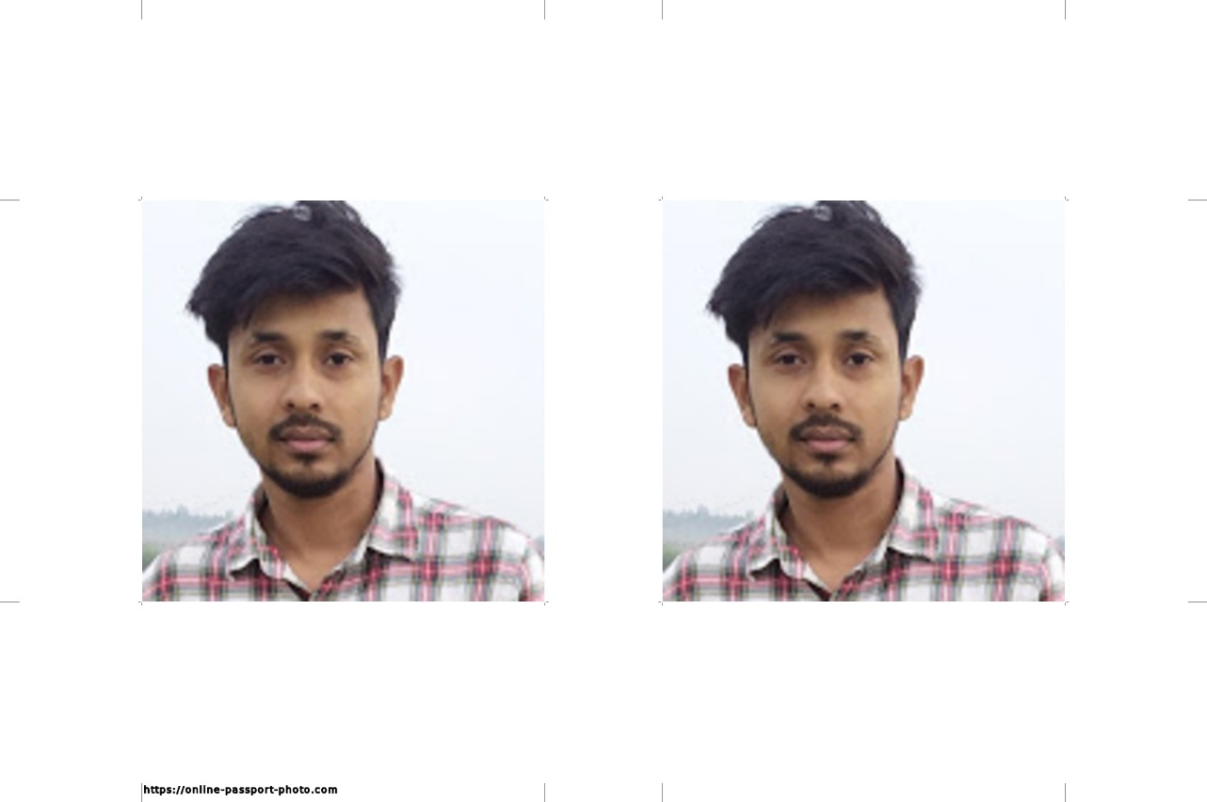

Faruqehassan7@gmail.com

MD.FARUQE HASAN

EXPERIENCE |

* HTML I have complete many type of simple project using

Just HTML

Please check my GITHUB link [CLICk](https://github.com/Faruqe560/classno-4.git)

* HTML I have complete many type of simple project using

Just HTML

Please check my GITHUB link [CLICk](https://github.com/Faruqe560/classno-4.git)

* HTML I have complete many type of simple project using

Just HTML

Please check my GITHUB link [CLICk](https://github.com/Faruqe560/classno-4.git)

* HTML I have complete many type of simple project using

Just HTML

Please check my GITHUB link [CLICk](https://github.com/Faruqe560/classno-4.git)

CAREER OBJECTIOVE |

To achieve self-actualization by shouldering adequate organizational responsibilities in order to fulfill organizational as well as personal goal and gain experience to work in any environment that will lead to the development of the organization.

|  |  |
| --- | --- |
| University | City University of Bangladesh |
| Subject | Computer Science & Engineering (CSE) |
| Passing Year | Running (10th Semester). |
| Result | CGPA: 3.07 (out of 4.00). |

EDUCATION

B.Sc.in CSE

EDUCATION |

|  |  |
| --- | --- |
| Institute | Nasingdi Technical School & collage |
| Board | Dhaka |
| Passing Year | 2016 |
| Group | Science |
| Result | GPA:4.69 (out of 5.00) |

HSC

|  |  |
| --- | --- |
| Institute | Nasingdi Technical School & collage |
| Board | Dhaka |
| Passing Year | 2014 |
| Group | Science |
| Result | GPA:4.39 (out of 5.00) |

HSC

|  |  |
| --- | --- |
| Name | Md.Faruqe Hasan |
| Father’s Name | Md.Shafi Uddin |
| Mother’s Name |  |
| Date of Birth | 03.11.1996 |
| Nationality | Bangladeshi |
| Marital Status | Single |
| Religion | Islam |
| Height | 5’7’’ |
| Blood Group | O+ |
| Permanent Address | Vill:Marjal, P.O: Raipura, P.S:Raipura,Dist:Narsingdi. |

PERSONAL INFORMATIONAL

REFERENCE’S

|  |  |
| --- | --- |
| Kazi Hasan Sakib  Department Head of CSE  City University of Bangladesh  Cell:01534660559 |  |